**Week 2**

**Exercise 2: Writing Basic JUnit Tests**

1. Creating a new Java class with some methods to test.

**Calculator.java**

**package** com.example.calculator;

**public** **class** Calculator {

**public** **int** add(**int** a, **int** b) {

**return** a + b;

}

**public** **int** multiply(**int** a, **int** b) {

**return** a * b;

}

}

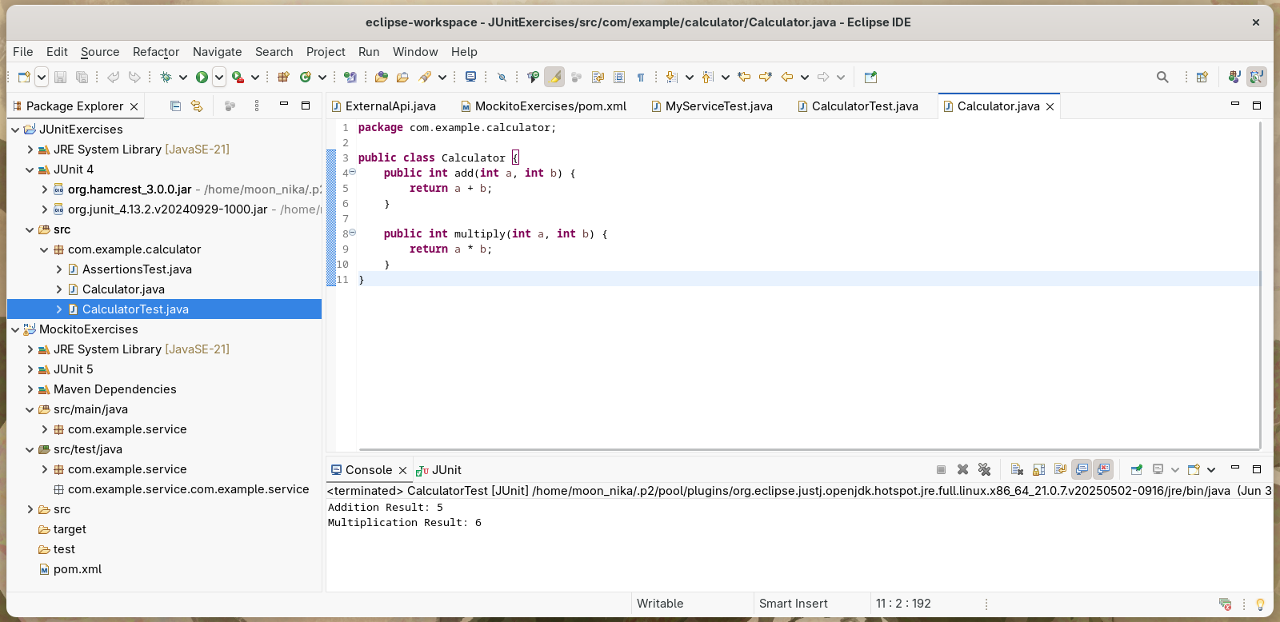

2. Writing JUnit tests for these methods.

**CalculatorTest.java**

**package com.example.calculator;**

**import static org.junit.Assert.*;**

**import org.junit.Before;**

**import org.junit.After;**

**import org.junit.Test;**

**public class CalculatorTest {**

**Calculator calc;**

**@Before**

**public void setUp() {**

**calc = new Calculator();**

**}**

**@After**

**public void tearDown() {**

**calc = null;**

**}**

**@Test**

**public void testAdd() {**

**int result = calc.add(2, 3);**

***assertEquals*(5, result);**

**}**

**@Test**

**public void testMultiply() {**

**int result = calc.multiply(2, 3);**

***assertEquals*(6, result);**

**}**

**@Test**

**public void testAddconsole() {**

**int resultadd = calc.add(2, 3);**

**int resultmultiply = calc.multiply(2, 3);**

***assertEquals*(5, resultadd);**

***assertEquals*(6, resultmultiply);**

**System.*out*.println("Addition Result: " + resultadd);**

**System.*out*.println("Multiplication Result: " + resultmultiply);**

**}**

**}**

